**Spartan6 - DSP48A1**

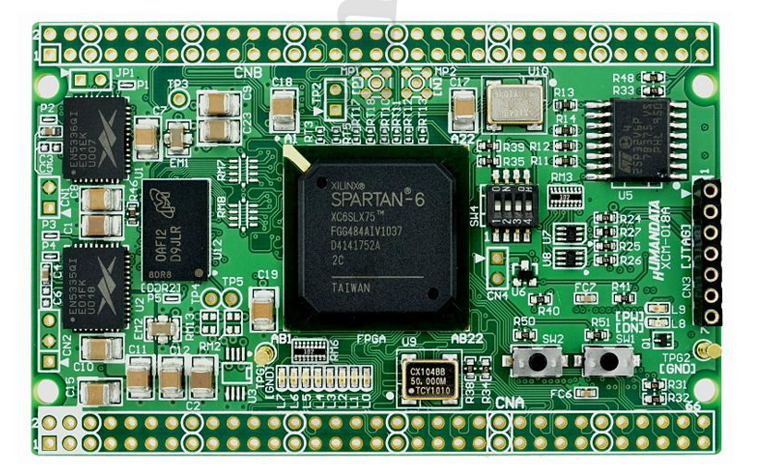

**Prepared by:** Mohamed Shaban Moussa

p

**Submitted to:** Eng. Kareem Waseem

**📧 Contact**

* **Email:** [**mohamedmouse066@gmail.com**](mailto:mohamedmouse066@gmail.com)
* **Linkedin:** [**Press Here**](www.linkedin.com/in/mohamed-s-moussa-ba0993285)

**Project Sources**

* **GitHub:** [**Press Here**](https://github.com/mohamedSmoussa/Spartan6---DSP48A1)

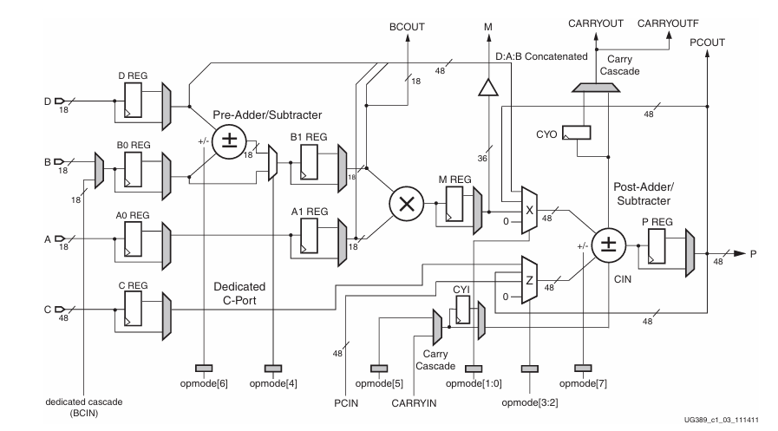

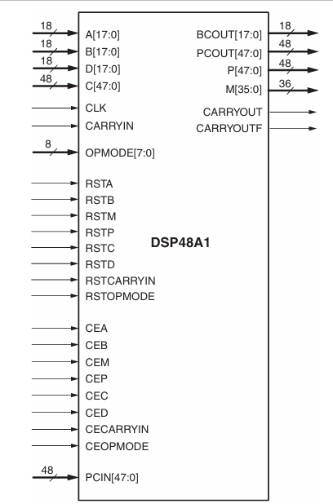

**CODE**

**REG_MUX_MODULE**

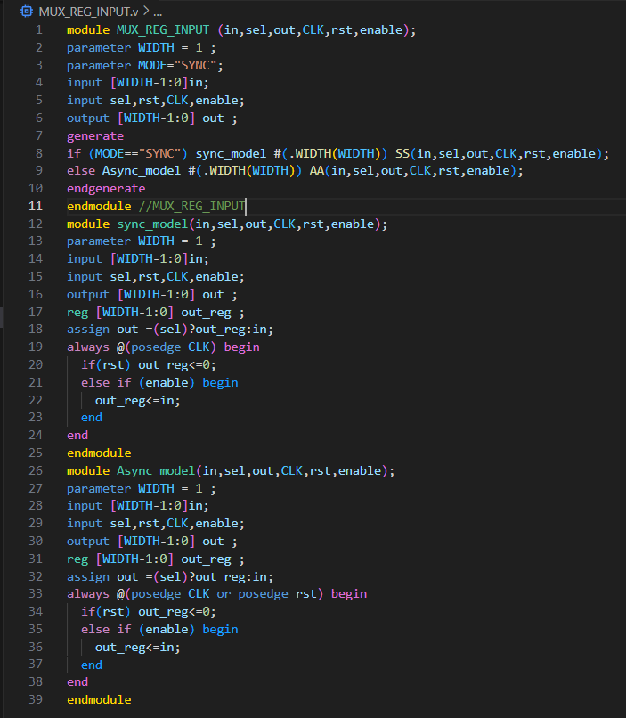

**4_TO_1_MUX_MODULE**

**do_file**

**RST_tb**

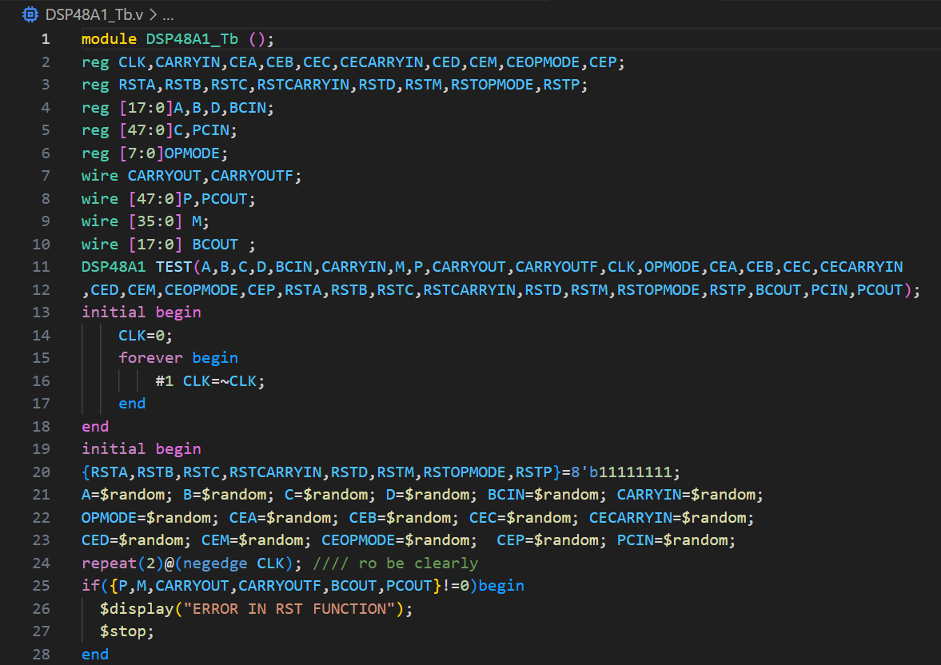

**RST_WAVE_PART**

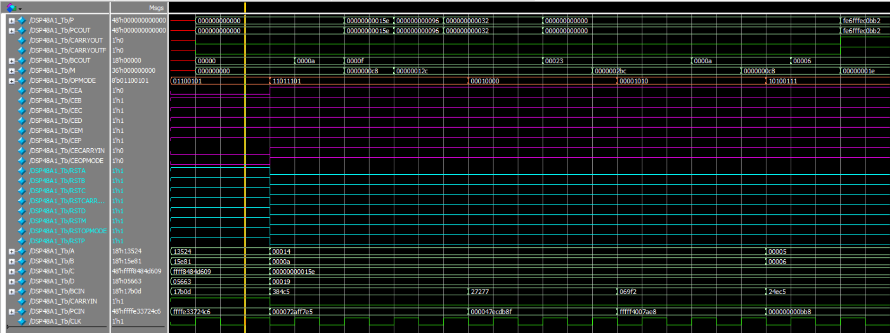

**PATH1**

**PATH1_tb**

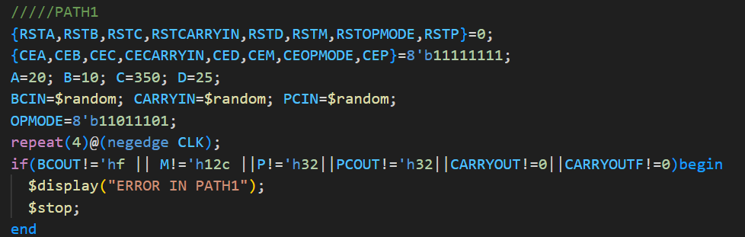

**PATH1_WAVE_PART**

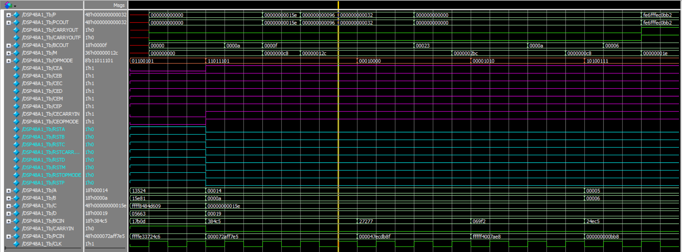

**PATH2**

**PATH2_tb**

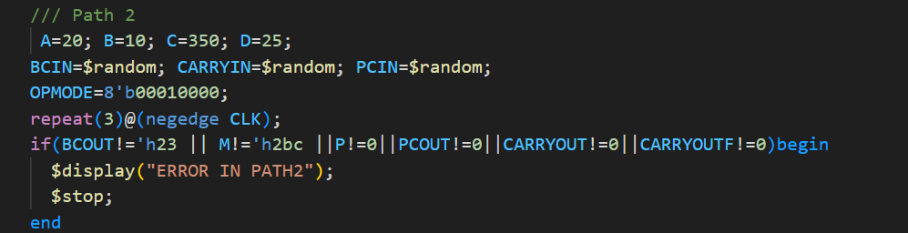

**PATH2_WAVE_PART**

**PATH3**

**PATH3_tb**

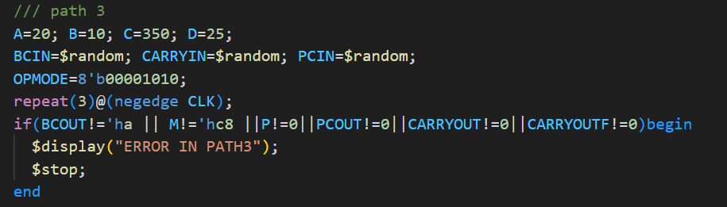

**PATH3_WAVE_PART**

**PATH4**

**PATH4_tb**

**PATH4_WAVE_PART**

**RTL_SCHEMATIC**

**RTL_NO_ERRORS**

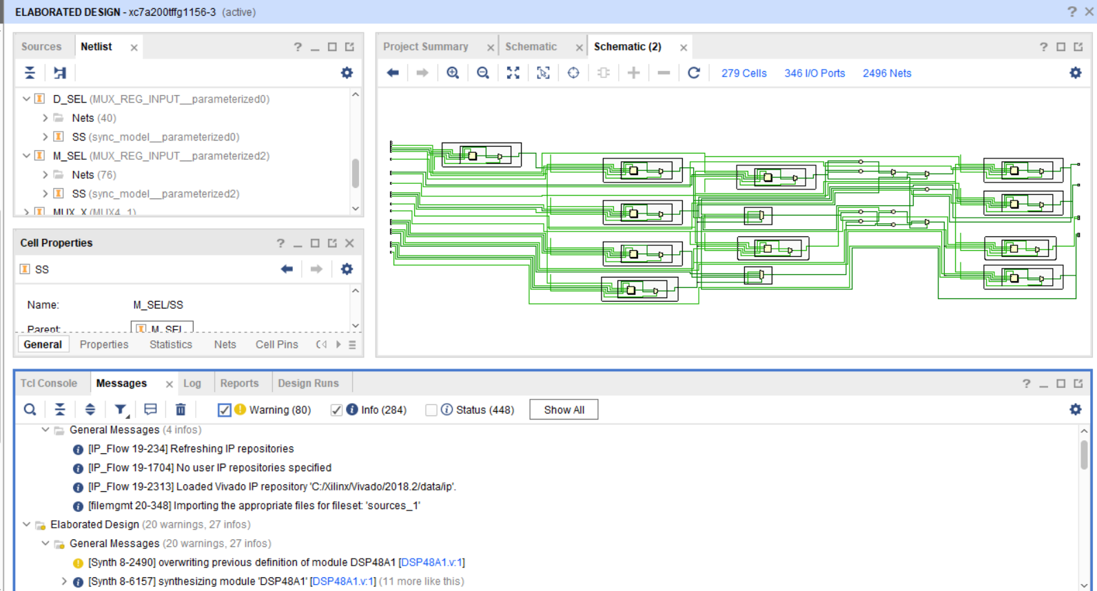

**SYNTHESIZED_NO_ERRORS**

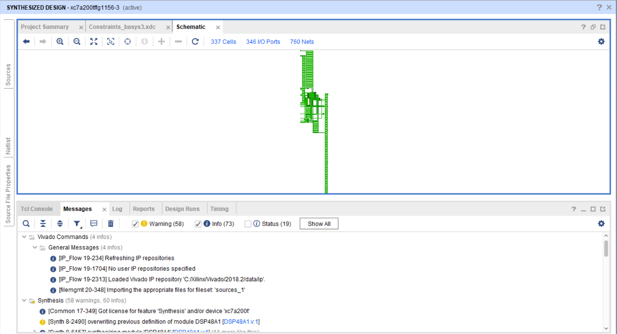

**SYNTHESIZED_SCHEMATIC**

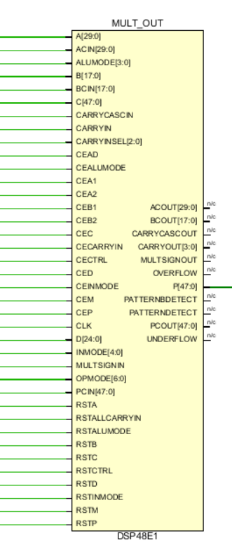 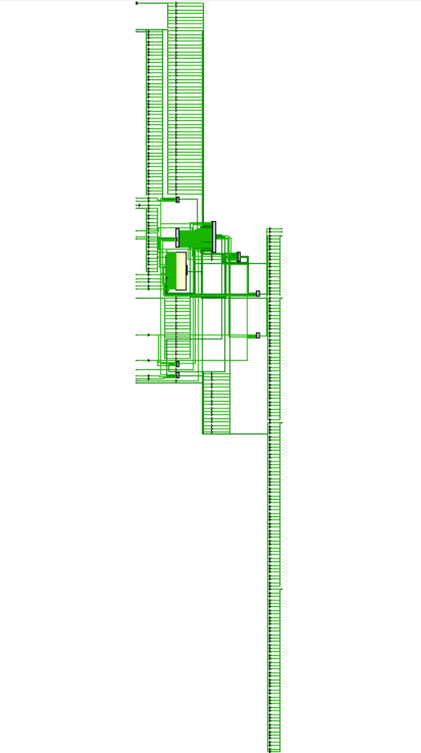

**SYNTHESIZED_TIME_REPORT**

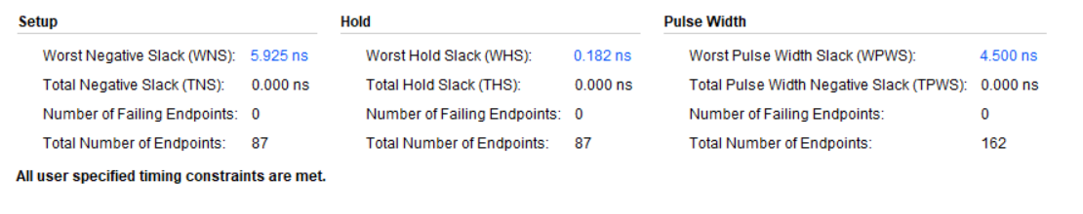

**SYNTHESIZED_UTI _REPORT**

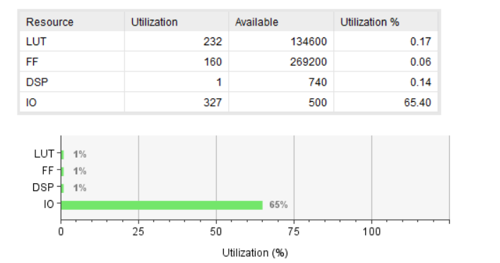

**DEVICE**

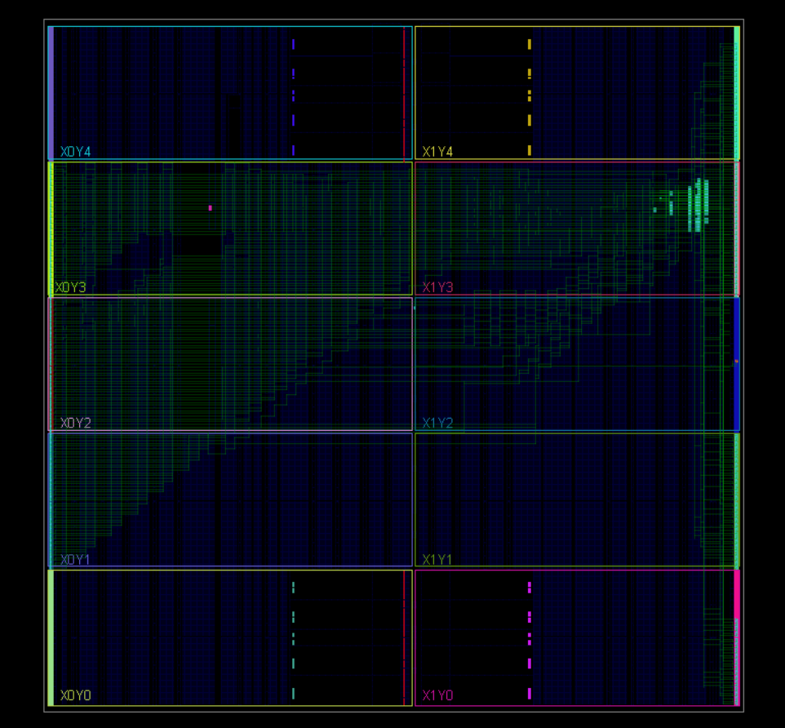

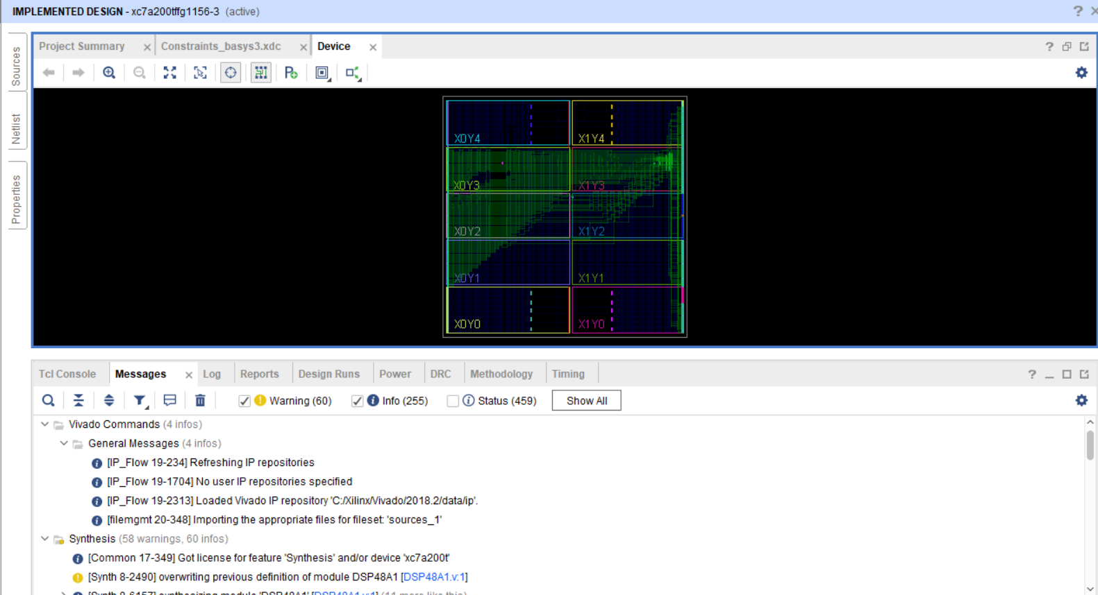

**IMP_NO_ERRORS**

**IMP_TIME_REPORT**

**IMP_UTI_REPORT**

**IMP_POWER_REPORT _REPORT**

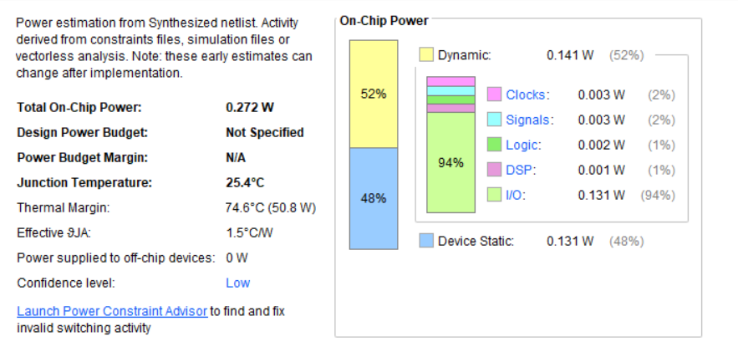

**Qlint_Snippet**

